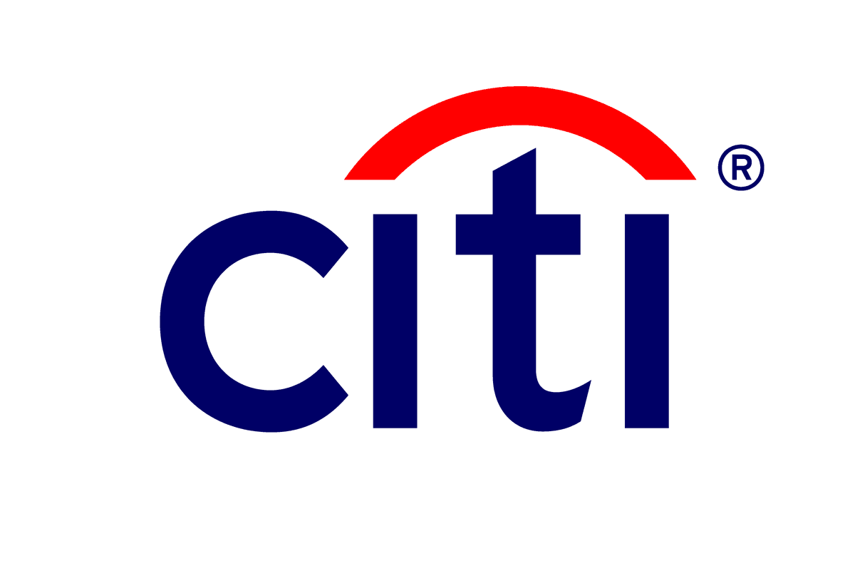

**AGREEMENT OF NON-EMPLOYEE**

**TO COMPLY WITH CITI POLICIES**

**I, THE UNDERSIGNED, HEREBY ACKNOWLEDGE THAT:**

* 1. I am an employee of, or an independent contractor providing services subcontracted to me by ________________________ (“Supplier”), which is providing Services to Citigroup Inc. or one of its affiliates or subsidiaries (“Citi”) pursuant to an agreement (the “Agreement”) executed between Supplier and Citi.
  2. In connection with my services to Citi, either Citi or its designated agent has provided me with access to the following materials in connection with my review of, and agreement to, this Agreement to Compliance with Citi Policies (this “Compliance Agreement”):
     + The Citi Code of Conduct
       - <https://www.citigroup.com/citi/investor/corporate_governance.html#code-of-conduct>
     + The Citi Foreign National Letter of Assurance to be completed herewith by me, (collectively, the “Related Materials”).
  3. Citi is a highly regulated company with business lines that operate within the banking and securities industries, and that certain laws and regulations may prohibit individuals who have or are currently engaged in certain types of behavior from performing services for or on behalf of companies in the banking and securities industries, such as Citi;
  4. Citi has adopted policies and procedures designed to adhere to applicable laws and regulations, and to protect Citi’s interests and those of its customers, employees, and business associates; and
  5. As a condition of my being permitted to perform any services for, or on behalf of, Citi, I must comply with all such corporate policies and procedures, whether they are implemented throughout Citi or are specific to the Citi facility or business unit where the services are performed, and as they may be changed from time to time by Citi, as well as with the laws and regulations of all countries in which Citi conducts operations.

**ACCORDINGLY, I DO HEREBY UNDERSTAND AND AGREE AS FOLLOWS:**

1. **Non-Employee Status.** I understand and agree that I am not an employee of any Citi entity and that my performance of services for, or on behalf of, Citi; my agreement to comply with the obligations in this Compliance Agreement; and/or my compliance with such obligations do not constitute employment or any promise of employment with Citi.
2. **Code of Conduct.** I understand and agree that in performing services for Citi, I must comply with the Code of Conduct that is provided in the Related Materials and otherwise act in accordance with the highest standards of personal and professional integrity in all aspects of my activities, including (without limitation) those specifically set forth in Citi’s Code of Conduct that is provided in the Related Materials. I further understand and agree that I must comply with all applicable laws, rules, regulations and Citi policies.
3. **Confidential Information.** I understand and agree that at all times while performing services for, or on behalf of Citi and thereafter, I will keep confidential and will not without advance written approval use, reproduce, remove or transmit, or otherwise disclose, either directly or indirectly, to any unauthorized individuals, including (without limitation), any Citi employee, non-employee worker or other third party, any personal, proprietary, confidential and/or secret information of Citi, including (without limitation) information about Citi or its business, products and services, methods, systems, and business plans, and information (including personal information) about any of its current, former or prospective employees, non-employee workers, clients, vendors and business partners (individually and collectively, “Confidential Information”).

I further understand and agree that Confidential Information as used herein includes (without limitation) pricing information, trading strategies, trade secrets, customer information, analytic models, banking transactions, account activity, new products in development, internal reports, any proprietary or licensed software, and “internal non-public information” under the federal securities laws of the United States, and other applicable laws.

I understand that I have an obligation to comply with Citi’s Information Security Standards and to safeguard Confidential Information, regardless of its form, including to protect it from misuse by third parties; not to disclose it to any unauthorized person; not to use it or permit it to be used for any unauthorized purpose; to collect, use, access, maintain, transport, transmit, and disclose it only for the performance of my assigned job duties in connection with my performing services for, or on behalf of, Citi; and to appropriately dispose of it in accordance with Citi policy.

I further understand and agree that upon the termination of my performing services for, or on behalf of, Citi for any reason, I will not disclose, use, retain or take with me any Confidential Information and will return immediately to Citi all Confidential Information and other Citi property and will not keep copies or duplicates (in any medium) of any of those items. I understand that I must, and I agree that I will, return all means of access to Confidential Information as well as return all Citi property, including but not limited to all ID cards, keys, telephone cards, credit cards, laptops, One Time Password (OTP) tokens (*e.g.,* SafeWord cards), cellular phones, PDAs, blackberries, fax machines, and any other means of accessing such information. Further, I understand that I may not, and I agree that I will not, forward such information to my home computer, my personal email address, or to any third party service provider or server or other non-Citi website, or engage in any other unauthorized use, misappropriation, or disclosure of such information.

Without limiting the generality of the foregoing, I specifically understand and agree that, under federal securities laws of the United States, and other applicable laws, Citi policies and procedures prohibit any person or entity from (i) trading any securities (including stocks, bonds, options or any other securities) when such person or entity has material non-public information about such securities or (ii) disclosing such information to any other person or entity; and, further, that if I violate such laws I may be subject to criminal prosecution, civil suits, imprisonment and/or significant fines.

I acknowledge and understand that nothing contained in this Agreement is intended to prohibit or restrict me or Citi from providing evidence or other information to any government, regulatory, or self-regulatory agency such as (without limitation) the Securities and Exchange Commission (“SEC”), the Commodity Futures Trading Commission ("CFTC"), The Department of Justice (“DOJ”), and the Financial Industry Regulatory Authority, Inc. (“FINRA”), or from responding to any court order or subpoena, or from participating in any reward program offered by any government, regulatory, or self-regulatory agency. I may also disclose confidential information, including trade secrets, to (a) any government, regulatory, or self-regulatory agency, including under Section 21F of the Securities and Exchange Act of 1934 and Section 23 of the Commodity Exchange Act of 1934 and the rules thereunder, or under Section 7 of the Defend Trade Secrets Act of 2016 (“Defend Trade Secrets Act”) or (b) an attorney in connection with the reporting or investigation of a suspected violation of law or to an attorney or in a court filing under seal in connection with a retaliation or other lawsuit or proceeding, as permitted under the Defend Trade Secrets Act. I understand that I do not need the prior authorization of Citi to make these disclosures or provide evidence or other information to any government, regulatory, or self-regulatory agency, and I am not required to notify Citi that I have done so.

**4**. **Electronic Communications Equipment and Services.** I understand and agree that to the extent I am provided access to any Citi electronic communications equipment, services, or facilities (including, without limitation, any technology, telephones, facsimile services, voice mail, computers, laptops, pagers, PDAs or Blackberries, email, intranet, Internet access, text and instant messaging and, other electronic communications tools, devices, data links and data services for on-site, mobile or remote use) (individually and collectively, “Electronic Communications Equipment and Services”) in order to perform services for Citi, Citi will have the right to monitor, record, limit, review, modify or terminate such access for any reason permitted by applicable law. Except as may be prohibited by applicable law, all communications, information, data, files, or click stream data that I create, send, receive, download, store, transmit, delete, or use while using Electronic Communications Equipment and Services are the property of Citi and may be used by Citi for any purpose. This includes any personal communications I send or receive through Electronic Communications Equipment and Services.

Citi may, in its discretion and consistent with applicable law, intercept, monitor, record, inspect, copy, access, or disclose (collectively, “monitor”) any or all of my activities and/or communications while using Electronic Communications Equipment and Services, whether on or off site (including remote work). This includes deleted e-mails and e-mails or other information stored on a computer hard drive. Monitoring may be periodic, random, or continuous.

Since my use of Electronic Communications Equipment and Services is always subject to monitoring as permitted by applicable law, I should have, to the extent allowed by such applicable law, no expectation of personal privacy when I use Electronic Communications Equipment and Services for any reason, including for personal use. To the contrary, I understand and agree that, as allowed by applicable law, my use of Electronic Communications Equipment and Services will likely be monitored in the normal course of business. Any improper or unauthorized use, removal, or theft of Electronic Communications Equipment and Services may result in the immediate termination of my services to, or on behalf of, Citi and/or criminal prosecution.

I further understand and agree that:

1. I may and will use Electronic Communications Equipment and Services to perform services for Citi and not for any purpose other than the legitimate business purposes of Citi, and I understand that personal use of Electronic Communications Equipment and Services, if any, must be very limited and must otherwise comply with the standards set forth in this Compliance Agreement. I specifically understand and agree that I may not use Electronic Communications Equipment and Services for any improper use, including (without limitation) (i) the downloading, transmission, storage or communication of content consisting of threats to safety of persons or property, unauthorized use or misuse of Confidential Information or ethnic slurs, racial epithets, hate speech, sexually explicit material, obscenities or anything else that may be construed as inappropriate, harassing or offensive to others based on an individual’s race, color, national origin, nationality, citizenship, creed, religion, gender, gender identity or expression, sexual orientation, marital status (including domestic partnership and civil unions as defined and recognized by applicable law), veteran status, age, disability, culture, ancestry, socioeconomic status or any other characteristic or status protected by law or Citi policy; or (ii) accessing any website, “chat room” or the like that includes any of the foregoing content, including (without limitation) pornography, off-color jokes, or hate speech.
2. I may not and will not transfer any access rights entrusted to me to any other individual.
3. I may not and will not attempt to obstruct, hamper, or obtain access to any Citi system, program or data other than for a legitimate purpose related to my performing services for, or on behalf of, Citi and only through the access granted to me by Citi in writing.

**5**. **Background Check.** I understand and agree that in connection with my performing services for, or on behalf of Citi, Citi may, as permitted by applicable law, require that I satisfactorily pass a criminal background check as a condition to performing such services, and that if I refuse to cooperate in such background check or do not pass it satisfactorily, I will not be permitted to perform any services for, or on behalf of, Citi in any capacity. Without limitation to the foregoing, by signing below I understand and agree that I have specifically disclosed, or will specifically disclose, to Citi in writing:

1. Any instance in which I was expelled, barred, enjoined, or prohibited from participating in the securities industry;
2. Any instance in which I was convicted of, pled guilty or nolo contendere (no contest) to, or participated in any pre-trial diversion for, any felony or misdemeanor involving any crime of dishonesty, breach of trust or money laundering, including (without limitation) any of the following:

|  |  |
| --- | --- |
| * The purchase or sale of a security | * Burglary |
| * Theft | * Perjury |
| * Possession or use of stolen property, including stolen credit cards | * Making a false statement to a Government official, law enforcement officer, or while under oath |
| * Forgery or Counterfeiting | * Robbery |
| * Bribery | * Extortion |
| * Embezzlement * Illegal manufacture, sale, distribution of, or trafficking in, a controlled substance | * Conspiracy * Fraud |

1. I hereby agree to immediately notify my Citi-designated business contact if, during the time period that I am performing services for, or on behalf of, Citi, I am arrested for, or charged with, any crime of dishonesty, including those listed above.

**6**. **Fraud.**  I understand that Citi has a zero tolerance policy towards fraud, the misappropriation of assets, service or benefits, the misrepresentation of financial condition, or any other dishonest or unlawful act. I am also aware that each non-employee must take all required and reasonable measures to prevent, detect, notify and escalate possible fraudulent activity. In addition, all non-employees are expected to conduct Citi business and operations in accordance with the highest standards of ethical conduct as described in the Citi Code of Conduct.

**7**. **Personal Accounts.** I understand and agree that in performing services for Citi, I may have access to certain Citi accounts, but that I am not permitted to access my account(s) or the account(s) that I know or believe to belong to any member of my family or of any co-workers, nor if access is provided, to make any changes whatsoever to any such accounts, including, without limitation, changes to name, address, credit limit, status code changes or notes. I understand and agree further that any activity that may create a perceived conflict of interest is prohibited. I acknowledge and agree that the following rules (as they may be updated or amended by Citi at any time) shall apply to my account access, and that my violation of these rules may lead to the immediate termination from my performing services for, or on behalf of, Citi. Accordingly, I agree that I must and will:

(a) Advise my Citi‑designated business contact if I find my account or an account that I know or believe to belong to any family member in my queue, so as to have the account moved appropriately;

(b) Contact Customer Service in any instance where I might need or want to change the name and address or the telephone number on my account or an account that I know or believe to belong to a family member or co-worker.

(c) Report to my Citi-designated business contact immediately if I come across an account that I know or believe to belong to a Citi employee or any co-worker in the course of my work.

**8.** **Brokerage Accounts for Designated Non-Employees.** To the extent allowed by applicable law, Citi requires the disclosure and review of activity within a “Covered Account” of all Designated Non-Employees (DNE). A DNE is defined in Citi’s Employee Personal Trading and Investment Policy for Citi Brokerage and Advisory Persons (ETP) and can include, but is not limited to, contractors, consultants and secondees working for areas considered Private-side business functions that create, receive, have knowledge of, or obtain access to, non-public information. The ETP defines a “Covered Account” as one in which a DNE and/or his/her “Related Persons” has the power to effect or the ability to influence trading or investment decisions (i.e. brokerage accounts), either directly or indirectly. I understand and agree that upon notification, if in my position at Citi, I am classified as a DNE, as defined by Compliance and Citi Policy, I will promptly complete the EMDD Onboarding process and disclose all covered accounts. Further, I authorize Citi to receive duplicate account statements, confirmations or the equivalent while I am performing services for, or on behalf of, Citi.

**9**. **Personal Data**. I understand and agree that Citi may be provided certain information by me, or by my assigning employer, that could be used (either directly or indirectly) to identify me, including (without limitation) my name, national identification number, and certain contact information such as my office address, e-mail address, phone/cell numbers, etc. (individually and collectively, “Personal Data”). In addition, I understand that Citi maintains computer systems in data centers and at other locations in various countries throughout the world, and that Citi, its affiliated companies and third parties may collect, store, process, disseminate or use my Personal Data in a manner that causes it to be transferred, processed or accessed from computer systems owned or operated by, or on behalf of Citi or its affiliated companies throughout its global computer network. I expressly acknowledge and agree to, subject to applicable law, Citi’s collection, storage, processing, dissemination or use, and destruction of my Personal Data for all legitimate business purposes, including (without limitation) those relating to my performing services for or on behalf of Citi or its administration of applicable policies or its vendor management program.

**10**. **Export (with Specific Obligations for Foreign Nationals).** I have received, read and completed the Letter of Assurance. I specifically agree to comply with all laws and regulations of all countries that regulate the importation or exportation of goods and technologies and, in particular, to comply with the Export Administration Regulations of the United States as they pertain to any technical data, computer software, or any product (or any part thereof), process, or service that is the direct product of any such technical data or computer software (collectively and individually, “Export Controlled Products”) to which I have access while engaged by Citi.

**11.** **Equitable Relief.** Without limitation to any of the foregoing, I understand and agree that any breach or threatened breach of the obligations set forth in this Compliance Agreement will subject Citi to immediate and irreparable harm, and, in addition to any other remedies, Citi shall be entitled to obtain equitable relief in the form of a temporary restraining order, temporary or permanent injunction, or any such other equitable remedy which may then be available. I further understand and agree that, in addition to any other remedies in law or equity Citi may have, in the event that I breach any of the terms set forth herein, my performance of services for or on behalf of Citi may be terminated immediately.

**12.** “Related Materials”:

1. Citi Code of Conduct: <https://www.citigroup.com/citi/investor/corporate_governance.html#code-of-conduct>
2. The Letter of Assurance (to be completed by me)

By signing this Compliance Agreement below, I agree that I have read and understand the obligations described in it and in the Related Materials; and I further agree to comply with each such obligation.

ACCEPTED & AGREED:

|  |  |  |
| --- | --- | --- |
| Signature: |  | |
| Print Full Name: |  |
| Date (MM/DD/YY): |  | |

**Citi Non-Employee LETTER OF ASSURANCE**

(Export Control Laws)

As a condition for me being engaged on assignment by Citigroup, Inc. or one of its subsidiaries (collectively “Citi”), all staff working within the U.S. and outside the U.S. are required to comply with the requirements of U.S. and non-U.S. export control laws, particularly the U.S. Export Administration Regulations (EAR). Export control laws govern the export and import of any technical data, software, or hardware (collectively “Export Controlled Products”) to which I have access while engaged by Citi. In order to ensure my compliance, I shall not disclose, export, re-export or otherwise transfer any Export Controlled Products without having first verified that Citi has U.S. export control authorization. If I have any questions about any export control restrictions of any country, I will contact my Citi Business Contact or the [ECUHelp](mailto:CMS123@imcnam.ssmb.com) mailbox for guidance or consult the [Export Control Unit](https://www.citi.net/EN/Pages/riskmanagement/ContentPages/Export-Control.aspx?src=/EN/operationsandtechnology/riskmanagement) website for information and [available training](https://www.citi.net/EN/Pages/riskmanagement/ContentPages/ECU-Training.aspx?src=/EN/operationsandtechnology/riskmanagement). Specific language regarding the EAR’s prohibitions and limitations can be found in the following three paragraphs:

(1) I acknowledgethat the EAR prohibits the disclosure, exportation, re-exportation, or transfer of any Export Controlled Products: (i) to any country, or to any citizens or residents of any country, that is included within Country Group E (Cuba, Iran, North Korea, Sudan, and Syria) on Supplement No. 1 to 15 CFR Part 740 (“Supplement 1”), or (ii) to the Crimea region of Ukraine or to any residents of the Crimea region of Ukraine. I have been advised that an up-to-date version of Supplement 1 is located at

<https://www.bis.doc.gov/index.php/documents/regulation-docs/2255-supplement-no-1-to-part-740-country-groups-1/file>.

(2) I also acknowledge that certain Export Controlled Products to which I may have access while engaged by Citi will have encryption functionality subject to additional export control restrictions. I specifically agree (i) not to use any Export Controlled Products with encryption functionality for any purpose other than for Citi’s internal use (which may include the development of new products), and (ii) not to disclose, export, re-export or otherwise transfer any Export Controlled Products with encryption functionality outside Citi or to any other destination or end user outside the United States or Canada without first verifying that such a transfer is legally authorized.

(3) I agree to comply fully with the prohibitions, limitations, and other requirements discussed in this letter of assurance both during my assignment with Citi and thereafter as it relates to my Citi assignment.

I understand that my failure to comply with the prohibitions, limitations, and other requirements set forth herein will expose me and Citi to civil and criminal penalties, including monetary fines, imprisonment, and other penalties. In addition, subject to applicable laws, I understand that any such failure by me shall constitute grounds for disciplinary action by Citi, including immediate termination of my Citi assignment.

I understand that the personal information requested below is being collected only to assist Citi in complying with U.S. export control laws. Depending on the information provided, there may be further steps that Citi will take to ensure compliance with such laws. I understand that I may be required to work on matters that do not involve Export Controlled Products until Citi confirms compliance with all such laws, but that the disclosure of the information below will have no other effect on my assignment with Citi.

I consent to the disclosure of the information provided below by Citi to U.S. government officials for the purposes of complying with U.S. export control laws.

Acknowledgment

|  |  |
| --- | --- |
| Signature: |  |
| Print Name: |  |
| Date (MM/DD/YY): |  |
| GEID/ID: |  |

If you are a citizen of Cuba, Iran, North Korea, Sudan, Syria or the Crimea region of the Ukraine, please complete the following:

Nationality and/or Residency Status:

|  |  |  |  |  |
| --- | --- | --- | --- | --- |
| a) | Country of Citizenship: |  | Date (MM/DD/YY): |  |
| b) | Type of Visa (as appl.): |  | Date (MM/DD/YY): |  |
| c) | Permanent Resident of: |  | Date (MM/DD/YY): |  |

CONFIDENTIAL